UNIT REVIEW: Cells and Systems

Name ______________________8____

VOCABULARY: Write the definition for the following terms

Organism | Unicellular | Multicellular | Chemical digestion | Mechanical Digestion
Nervous Tissue | Muscle Tissue | Epithelial Tissue | Connective Tissue | Organelle
Diaphragm (muscle) | Autonomic Nervous System | Somatic Nervous System

QUESTIONS: Answer in point form or, when necessary, with drawings

- Explain what Darwin’s finches can tell us about “structure” and “function”
- The smallest unit of life is the cell. Use a flow chart to show how cells combine to form organisms
- Name and briefly describe the 6 characterisitics of living things
- Explain how osmosis and diffusion are similar. What is different about them?
- Name the different structures of a compound light microscope and describe BRIEFLY their function
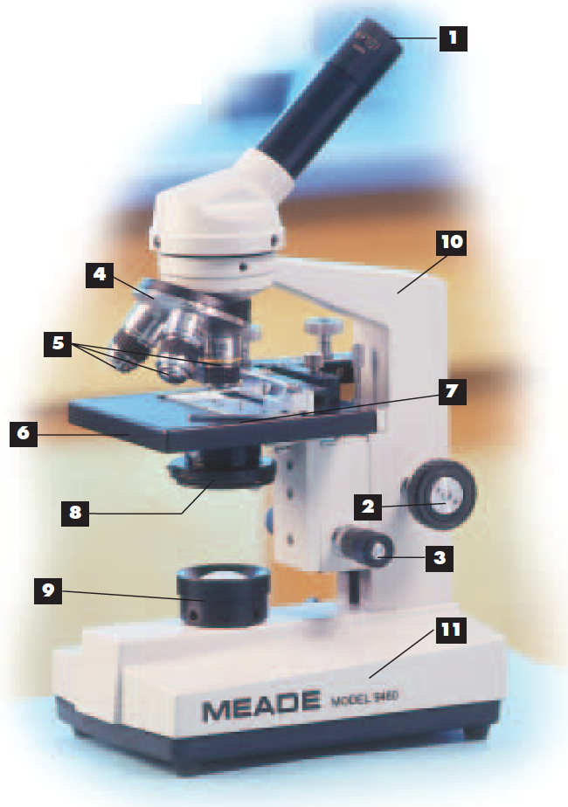
- What happens when you move a slide that you are viewing under a microscope? What direction does it move?
- Plant and animal cells have organelles that are either completely different, or just different in structure. Descirbe the differences between plant and animal cells.
- The tissue that supports the different parts of the body, including blood, fat and bones:
- Describe how nutrients are passed from the intestines into the blood stream
- Describe how the circulatory system and the respiratory system are connected. Include key words and structures.
- Name the MAIN arteries and veins that are directly attached to the HEART. Describe their function.
- Explain how dialysis can help someone who has an issue with their excretory system
- What is the reflex response? What controls it?
- Name a disease that impacts not just 1, but 2 of our body systems at the same time. Describe the impact.
- Who are Louis Pasteur and Edward Jenner. What is their scientific/medical claim to fame

