Topic 2 Notes: STRUCTURE & ADAPTATION

Plants are found in all habitats on Earth, each with a unique set of characteristics. These can include:
- _______________________________
- _______________________________
- _______________________________
- _______________________________

The plants _______________________ will help it to ________________ to these conditions. Plants are living things and need to survive in their own way.

The following types of plants have very unique survival strategies. Use your device to determine the differences between:

Perennials | Annuals

We will look at 3 plant structures in this topic and determine how they allow plants to adapt to their unique habitat; roots, stems, and leaves.
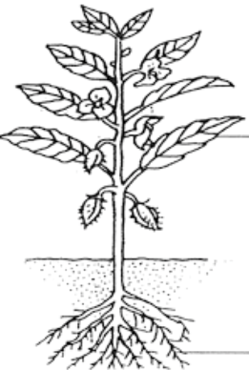 | How do you think each of these structures function to improve plant survival?  Leaves –  Stem –  Roots –
Check out the PowerPoint on CampbellCorner to complete notes on structures http://campbellcorner.weebly.com/2-structures-and-adaptations.html

Roots
Roots perform several important functions, including:

There are 2 types of plant systems: 1) Fibrous Roots, and 2) Taproots. Label the diagrams below identifying each type of root and their functions.

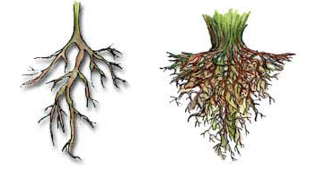

Functions: |  | Functions:

RESEARCH BREAK (Prepare to Share)
Moss Campion and Duckweed are 2 types of plants that have unique root systems. You can read about these systems on page 105 of your textbook. Using a device, research another plant that has a peculiar or unique root system (hint: keywords to look up include weird, unique, peculiar, crazy AND root systems)

Roots & Humans
Humans use the roots of plants in a variety of ways. The most common use is by growing ____________ __________. These typically grow over a short period of time and can survive in areas where there is less rainfall. Some common root crops that can be grown in Alberta include:

LAB BREAK - You can find your lab partners for this unit on the back chalkboard.
You will complete the lab on page 106 of your text. You do NOT have to write a formal lab report for this lab; however, you must provide ALL qualitative and quantitative data and answer the questions “What did you find out?” numbers 1-3.

Lab Prep Day___________________________________________
Lab Work Day _________________________________________
Due Date _______________________________________________

