Structures and Forces
Grade 7 Unit Exam

April 2012

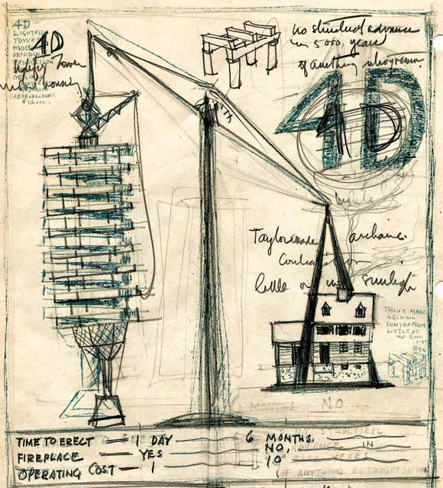

*Please mark all of your answers on the SCANTRON sheet
with a dark pencil

**DO NOT WRITE in this test booklet.

*** If you have any questions or concerns please
RAISE YOUR HAND and wait for the teacher to respond
STRUCTURES AND FORCES - UNIT TEST
Take your time. Read each question carefully.

PART 1: TRUE OR FALSE (15 marks)
Please indicate whether the following statements are either (A) true or (B) false on your Scantron sheet.

1. Structures are objects that have a definite shape and size, which serve a definite purpose or function.

2. Forces are a push or pull, or anything that causes a change in the motion of an object.

3. Load is the shape and size of a structure and the materials it is made of.

4. A margin of safety is the need for a manufactured structure to be able to withstand heavier loads or stresses than would normally be expected.

5. Lamination is a process in which layers of wood are nailed together to form a single layer of material.

6. Soldering is the same as welding.

7. A triple beam balance is a device used to measure the force of gravity.

8. Deformation is the change in the shape or size of an object when a force acts on it.

9. Tensile strength is the largest compression force an object can withstand before losing its shape or breaking into pieces.

10. Primary standard is the name given to a small cylinder of metal on which the kilogram is based, which has a mass of 1 exactly one kilogram.

11. Function is the main purpose of an object or a structure.

12. The centre of gravity is the point in which all of the gravitational forces of an object may be considered to act.

13. Footings are large, cylindrical structures used to carry the weight of a structure down through the loose soil until they rest on bedrock.

14. A gyroscope is a circular device that demonstrates the principle of spin stabilization by spinning on its axis in a predictable manner.

15. A natural structure is a structure that is constructed by humans.
MULTIPLE CHOICE (20 marks)
Mark the letter of the correct answer on your Scantron sheet.

16. A composite material is:
(a) chemically treated to resist water
(b) heated and cooled multiple times to increase its strength
(c) a material with multiple uses
(d) made of more than one kind of material

17. A diving board is an example of a
(a) Cantilever
(b) Keystone
(c) Brace
(d) Flying Buttress

18. Animal bones are often hollow or filled with a very lightweight material. This is because
(a) It decreases the dead load of the animal
(b) It increases the dead load of the animal
(c) It decreases the live load of the animal
(d) It increases the live load of the animal

19. Ropes or chains are good materials for pulling objects because
(a) they have a high compressive strength
(b) they have a high tensile strength
(c) they have a low tensile strength
(d) none of the above

20. To anchor the posts of a swing into the ground, we use concrete because
(a) It does not rot when it gets wet
(b) It has a high compressive strength
(c) It has a high tensile strength
(d) a and b

21. Mass and weight are often confused with each other, but there is a definite difference. How would this difference best be described?
(a) Mass is the amount of gravity acting on an object, and weight is the amount of material the object is made of.
(b) Mass is dependent on distance between two or more objects, and weight is always constant (or the same).
(c) Mass is dependent on the volume of an object, and weight is always constant.
(d) Mass is the amount of matter an object is made of, and weight measures the force of gravity on the object

22. When two sticks are rubbed together, they get hot. The force responsible for creating this heat energy is
(a) tension forces
(b) torsion forces
(c) friction forces
(d) shear forces
23. Which of the following inventions does NOT utilize interlocking shapes:
(a) Lego™ blocks
(b) Velcro™
(c) Ziploc™ freezer bags
(d) Post-it™ notes

24. What unit is force measured in:
(a) Newtons
(b) Kilograms
(c) Pounds
(d) None of the above, forces cannot be measured.

25. What unit is mass measured in:
(a) Newtons
(b) Kilograms
(c) Pounds
(d) None of the above, mass cannot be measured.

26. What unit is weight measured in:
(a) Newtons
(b) Kilograms
(c) Pounds
(d) Grams

27. Which of the following statements is true about shell structures
(a) uneven cooling of shells formed from hot or moist material can cause some areas to push and pull on nearby sections, strengthening the shell.
(b) small scratches cannot affect the strength of a shell
(c) igloos are shell structures and frame structures
(d) the shape of a shell spreads the forces of a load throughout the structure

28. Which of the following would be an example of a dead load of a house?
(a) the sink in the kitchen
(b) a bird sitting on the windowsill
(c) the car parked in the garage
(d) the water in the pipes and taps

29. Which of the following statements is true:
(a) Steel has a low tensile strength
(b) Graphite has a high shear strength
(c) Rubber has a high torsion strength
(d) a and b

30. A fulcrum is:
(a) the live load carried by a structure
(b) the handle of a lever
(c) the dead load carried by a structure
(d) the pivot of a lever

31. A piling is:
(a) a large cylindrical structure that is used to carry the weight of a structure to a solid foundation material.
(b) a wide base for a wall that is used to spread the weight over a larger area.
(c) a layer in a road base.
(d) all of the above.

32. A footing is:
(a) a large cylindrical structure that is used to carry the weight of a structure to a solid foundation material.
(b) a wide base for a wall that is used to spread the weight over a larger area.
(c) a layer in a road base.
(d) none of the above.

33. What is the weight of a 10 kg mass on Earth, where the acceleration of gravity is 9.8 m/s²? (note: Force = Mass times Acceleration)
(a) 9.8 N
(b) 98 N
(c) 9.8 m/s²
(d) 98 m/s²

34. A nail hammered into a block of wood is difficult to pull out because of
(a) tension forces
(b) torsion forces
(c) friction forces
(d) shear forces

35. Objects are more stable if:
(a) they have a wide base
(b) they have a low center of gravity
(c) they spin slowly
(d) a and b

PICTURE TIME! (8 marks)
Use this image of a beaver dam to answer questions 36 and 37:
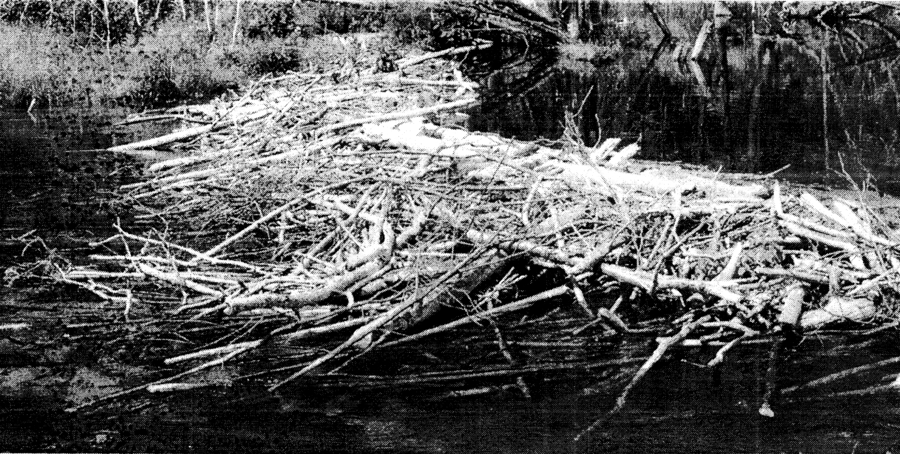
36. This beaver dam is a:
(a) natural structure
(b) manufactured structure

37. What kind of structure is this?
(a) frame
(b) shell
(c) mass
(d) frame and shell
Use the cola can image to answer questions 38-40:

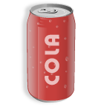
38. If you shake this can of cola, what kind of force would you be applying to the can?
(a) external force
(b) internal force

39. What kind of structure is the can (without the cola)?
(a) mass structure
(b) frame structure
(c) shell structure
(d) liquid structure

40. If you stepped on this can and crushed it, the type of internal stress that caused the can to buckle would be a _____________ force.
(a) torsion
(b) tension
(c) compression
(d) shear

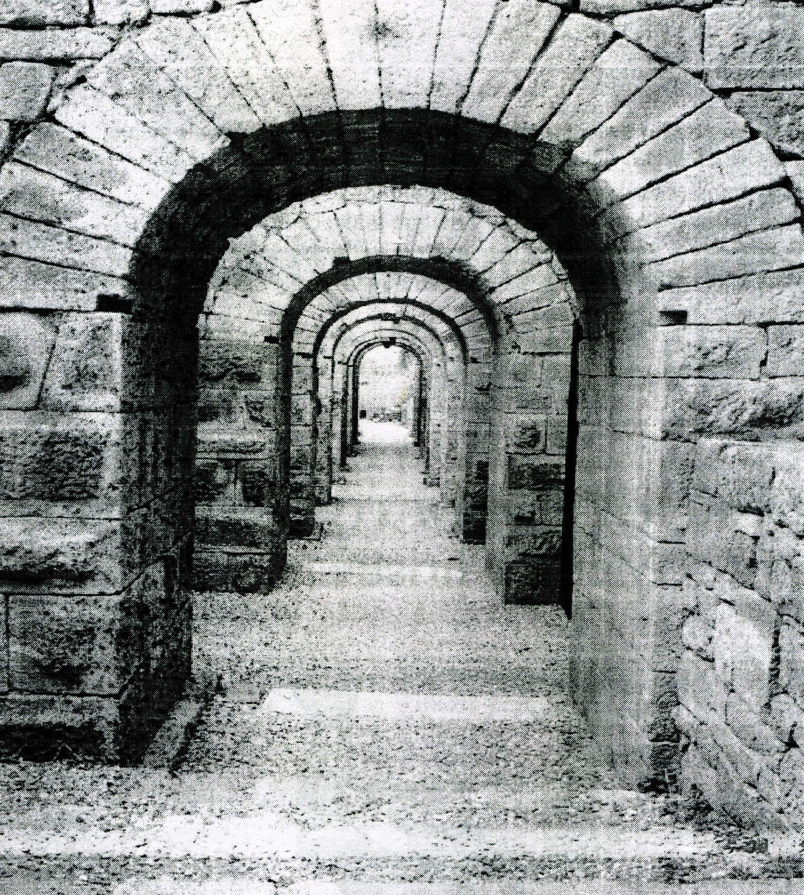
Use this image to answer questions 41 and 42.

41. How is the load above the arch distributed in the arch shown here?
(a) down and out to the sides
(b) up and into the middle
(c) down and into the middle
(d) up and out to the sides

42. The central stone of this arch is called a __________?
(a) Cantilever
(b) Keystone
(c) Wicked Wedge
(d) Flying Buttress

Use this image to answer questions 43 and 44.
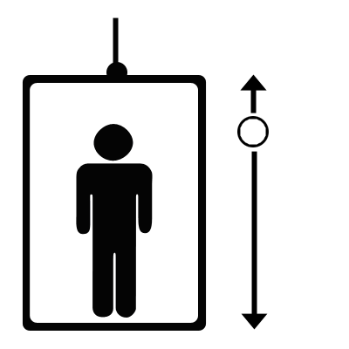
43. The diagram to the left is called a:
(a) gravity diagram
(b) mass diagram
(c) force diagram
(d) none of the above.

44. In the diagram, the elevator is:
(a) moving up
(b) moving down
(c) not moving
(d) slowly rising

45. An example of a rigid joint would be:
(a) door hinges
(b) tied shoe laces
(c) human shoulder
(d) a and b

46. Which of the following statements about adhesives is FALSE:
(a) Thermosetting glues harden when they cool
(b) Solvent-based glues harden as they dry out
(c) The strongest glues also create a special kind of force between the tiniest particles of the pieces being joined
(d) The strongest joints never fail, even under extreme conditions

47. When an object is bent, two internal forces or stresses act on the structure. In the example of the ruler below, which two forces are acting on it (note: the ruler is bent straight and not twisted)?
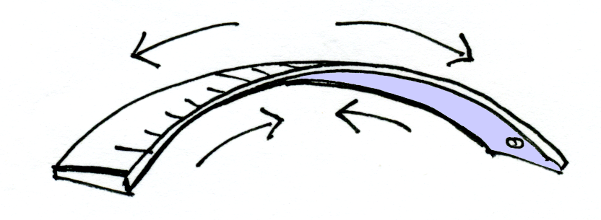
(a) Tension, Torsion
(b) Tension, Compression
(c) Torsion, Compression
(d) Tension, Shear

48. Which of the following would be a live load of a car?
(a) the doors
(b) the windshield
(c) the gas
(d) b and c

