Science 7 – Course Outline
St. Ambrose School 2015-2016

Teacher: Ms. Campbell/Mrs. Bohaychuk
amanda.campbell@cssd.ab.ca
amber.bohaychuk@cssd.ab.ca

Course Overview:
The Science 7 program is organized into 5 units that address the primary vision of the Alberta Program of Studies. Diverse learning experiences within the science program provide students with opportunities to explore, analyze and appreciate the interrelationships among science, technology, society and the environment, and develop understandings that will affect their personal lives, their careers and their futures. Students will be introduced to concepts in a variety of ways, including experimentation, research and critical thinking, with integration of technology.
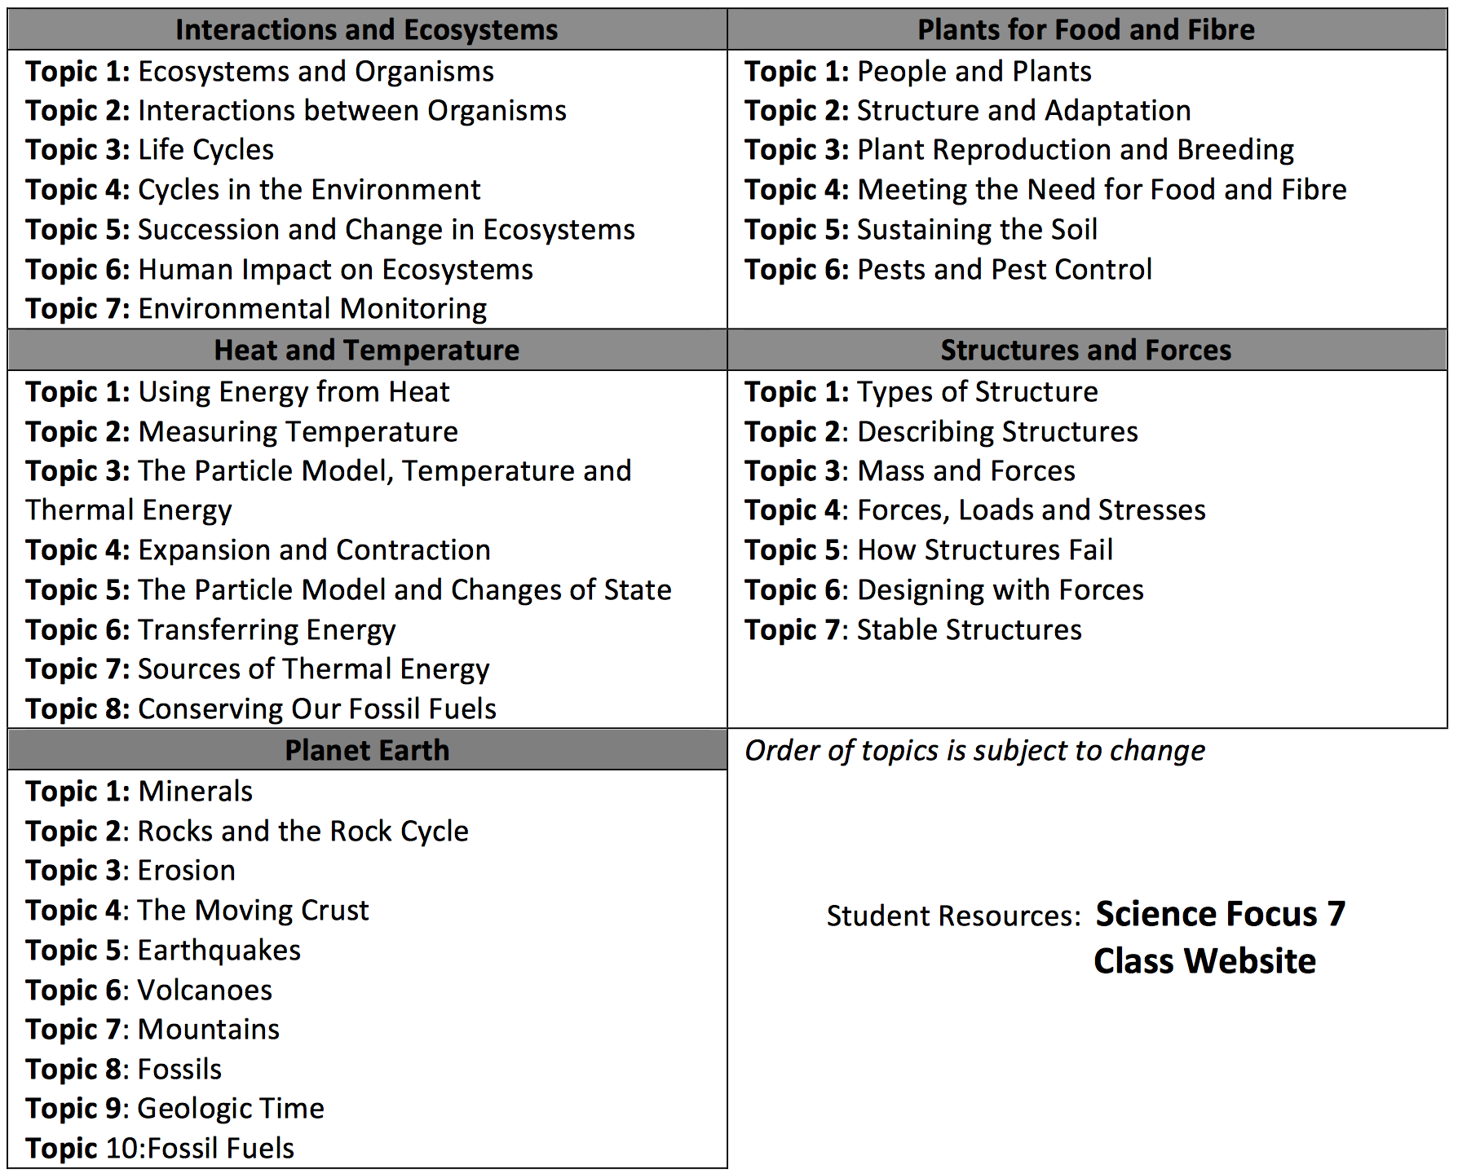

Student Resources: Science Focus 7 Textbook
Classroom Websites (weebly)
Campbell Corner (www.campbellcorner.weebly.com)
Bohaychuk (www.mrsbohaychuk.weebly.com)
Remind Updates (www.remind.com)
Ms. Campbell’s Remind (587) 409-3006 @sci8cam
Mrs. Bohaychuks Remind (587) 409-5765 @sciencebo
Supplementary notes/resources www.edquest.ca
 | Course Evaluation
 | Unit Exams | 20%
 | Tests/Quizzes | 10%
 | Critical Challenges | 30%
 | Mythbusters | 15%
 | Classwork | 10%
 | Final Assessment | 15%
General Information
Notes, handouts and assignments MUST include your name and date, whether you hand it in or not. Notes and handouts are to be kept in a neat and tidy order in your Science binder throughout the year. I will conduct random binder checks to ensure that this is done. All assignments and projects are to be completed on time. Students are responsible for class work and/or assignments missed in the event the student is away from school.
Incomplete/Late Assignments
All work will be submitted on the due date; students will then have the opportunity to complete their assignments during scheduled time at the school. If students do not hand any work in on the assigned due date, they will only be allowed to submit work completed during this time (they cannot complete it at home AFTER the due date). This policy ensures that students have a full understanding of the material. Extensions will be granted, upon my discretion, to those students who seek additional time IN ADVANCE of the assigned due date.
Classroom Expectations
- Arrive on time with all required materials and be prepared to listen, work and participate.
- Submit ALL assignments on time, and always include your name and the date.
- Only quality work is accepted and marked – some assignments may have to be resubmitted during designated time before they are given a mark.
- Respect yourself and others.
- Be aware of your rights and responsibilities as a student in this classroom.
I hope that you will have a very successful, productive and enjoyable year. Please feel free to ask for clarification on any class work or assignments that you are experiencing difficulty with. I look forward to a great year!

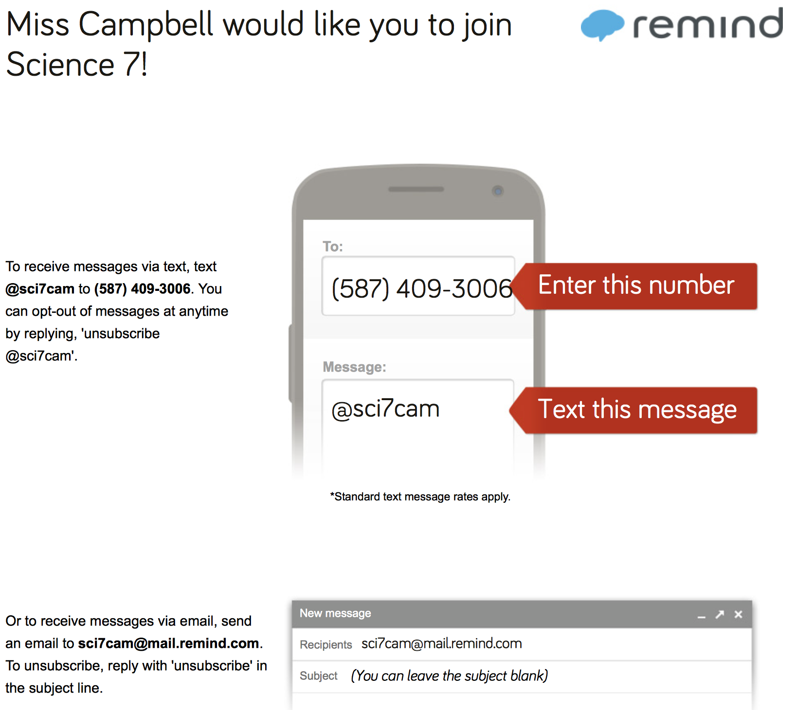

For quick access to CampbellCorner, scan the QR code:

