Biological Diversity Date _________________________________
2.2 Reproduction

Reproduction is essential for the survival of a species. There are 2 different categories for reproduction:
- _______________________________________
- _______________________________________

Asexual Reproduction: _________________________________________ and doesn’t require the fusion of sex cells.
The offspring is ____________________ to its parent as a result of this process.

4 Types of Asexual Reproduction:
1) Binary Fission _____________________________________________________________________________________________________
Binary fission 2 ________________ individuals.
Draw the process of binary fission here (additional image on CampbellCorner)

2) Budding _________________________________________________________________________________________________________
_______________________________________________________________________________________________________________________
Coral grows through the process of asexual budding. Explain how coral reefs grow by referring to your text (Page 30). Use images to aid your description.

3) ____________ ___________________: Reproductive cells are produced through the _________ ____________________ of parent cells.
One plant can produce MANY spores, and each spore will ______________________into a new plant _____________________ to the parent plant.

4) Vegetative Reproduction: reproduction of seed plants that ________ ______ involve the production of seeds. Plants reproduce from:
  - Stems and roots
  - Runners: ______________________________________________________________________________________________
_________________________________________________________________________________________________________
  - Rhizomes: ____________________________________________________________________________________________
_________________________________________________________________________________________________________
2 other types of Vegetative Reproduction include cutting and grafting. Draw and label the processes of cutting and grafting below:
Cutting | Grafting

What is SEXUAL REPRODUCTION?
Sexual Reproduction is _______________________________________________________________________________________________________________________
_______________________________________________________________________________________________________________________
_______________________________________________________________________________________________________________________
- Sexual reproduction relies on the ________________ of sex cells called ___________________
- __________________________ of the parents will have mixed ___________________________ (as we have learned through our discussion on genetic diversity).

Sexual Reproduction of ____________________
- Male gametes are called __________________
- Female gametes are called ___________________ or _________
When a sperm and egg cell come together this is called ______________________________.
Only 1 sperm cell can fertilize an egg cell.

The cell created through _________________________ is called a __________________.
- A zygote is formed right when the 1 sperm cell enters the egg
- The egg then gives off a ____________________ that keeps the other sperm from fertilizing it
- The zygote is the first cell of a new individual
- The zygote then divides into __________________
  - ____________________ are repeated through a process called _____________________
- The zygote then turns into a ______________________________________.
  - Depending on the species the development of the ___________________ can occur inside the female parent or ___________________ the parents in an _________.
Use the space below to (APPROPRIATELY) draw the formation of an individual using sexual reproduction. Use the image on the slides or Page 32 of your text as support.

Sexual Reproduction of ____________________

______________________________: The transfer of pollen from the male pollen sacs to the female __________________
Flowers function to _____________________ pollinators with colourful ______________________, _______________________, ________________________ and ________________________.

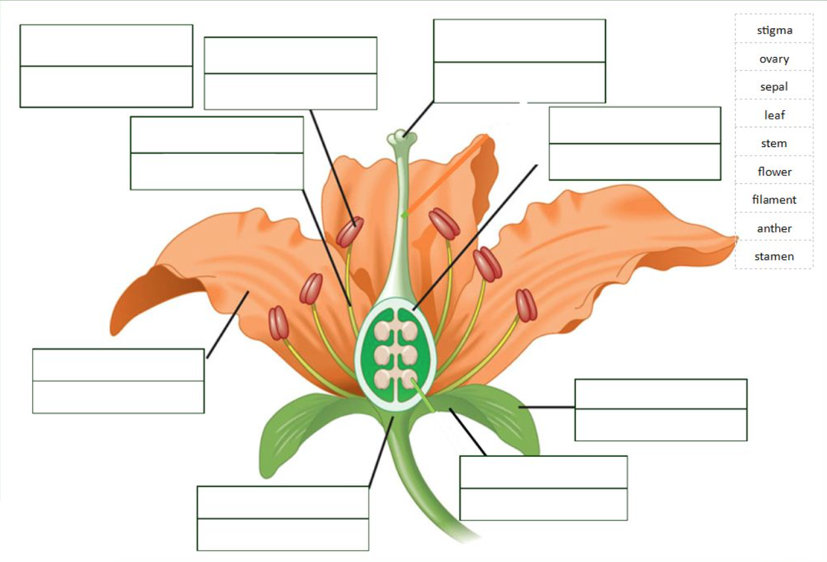

Female Reproductive Organs
Stigma – ______________________________________________________________________________________________________________
Style – ________________________________________________________________________________________________________________
Ovary – _______________________________________________________________________________________________________________
Ovules – ______________________________________________________________________________________________________________

Flowers have both male and female parts, and are called __________________ _________________.
In order to prevent self-pollination, plants use three strategies:
- ______________________________________________________________________________________________________________
- ______________________________________________________________________________________________________________
- ______________________________________________________________________________________________________________

Pollination and fertilization:
For pollen to successfully fertilize the egg, there must be ____________-____________________________
- Pollen sticks to the ___________________, starts growing a ___________________ ____________
- Cross-Fertilization begins when the tube begins to grow ___________________ the egg

Animal Pollinators
Insects – ______________________________________________________________________________________________________________
Birds – ________________________________________________________________________________________________________________
Mammals –___________________________________________________________________________________________________________

The shape and form of pollen is related to its method of pollination…
________________________ - pollinated species have sticky of barbed pollen grains
__________________ - pollinated species are lightweight, small and smooth (corn pollen)

ReSearch Break… Globally, we are seeing many of our pollinators die off. Colony Collapse Disorder is impacting our crops and economy severely. What is colony collapse disorder? How are we feeling the impact here in Canada compared to the rest of the world? What would you do to “fix the problem”?

ASEXUAL REPRODUCTION
Advantages | Disadvantages
SEXUAL REPRODUCTION
Advantages | Disadvantages

