Pythagorean Puzzle
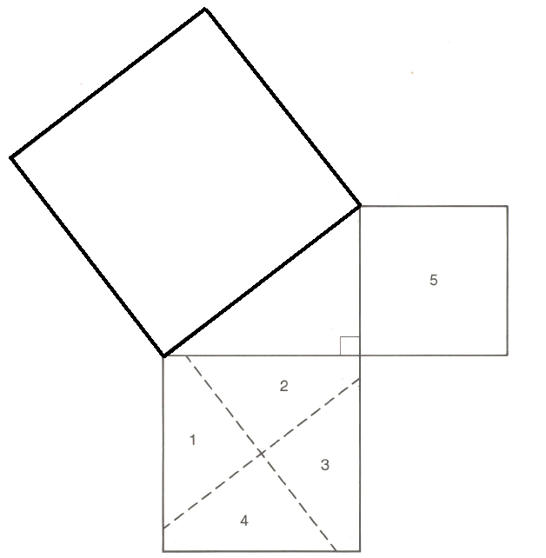

Pythagorean Puzzle
1) Cut off the small and medium squares. (Numbered 1-4 and 5)
2) Cut the medium square along the dotted lines.
3) Try to arrange the pieces (1-5) inside the larger, darker square.

What can you conclude from this exercise? ____________________________________________________________________________________________________________________________________________________________________________

Glue or tape your puzzle here

