Circulatory System: Major Features: Heart, arteries, veins, capillaries

The circulatory System is your body’s transportation network. It transports blood throughout the body. It provides your body with nutrients and oxygen, while also removing waste and protecting from illness. The liquid “blood” that flows through this system is called plasma.

There are 3 types of blood cells in our bodies: 1) Red Blood Cells transport nutrients & oxygen, 2) White Blood Cells fight infection, and 3) Platelets are cells that stop bleeding (form a clot) when you are cut.

The Heart is a hollow, muscular organ that pumps blood throughout the body. Each pump pushes blood through a series of networks called vessels.

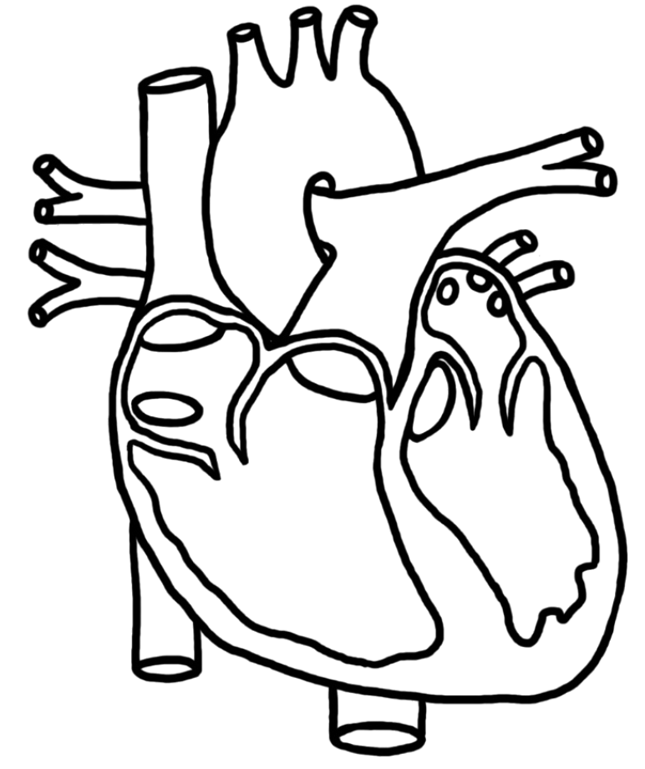

Septum – a wall that separates the right side from the left side
Pacemaker – a group of cells located in the right atrium that sends a signal to make your heart muscle contract.

Valves – Separate the atria from the ventricles and prevent blood from flowing backward

* Label each of these parts on the diagram.

Pattern of Blood Flow: The heart circulates blood through two separate loops. One takes blood to the body and the other takes blood to the lungs.
Transporting Blood
Your heart has to pump blood through 100 000 km of blood vessels. The vessels that carry blood away from your heart to all the parts of your body are called arteries. Blood is returned from your body to the heart in veins. Microscopic vessels called capillaries connect your arteries and veins. Blood cells can only travel in single file through these tiny vessels, which allows gases and nutrients to diffuse in and out of them easily!

Lab: Heart Rate Name________________________8_____

Problem: How is your heart rate impacted by various forms of physical activity?

Hypothesis: ________________________________________________________________________________________________________
_______________________________________________________________________________________________________________________
_______________________________________________________________________________________________________________________

Materials: Timer/Stopwatch

Procedure:
- Determine the best location to record your heart rate (find your pulse – neck or wrist)
- While sitting, count your pulse for 20s (Mrs. B will tell you when to stop). Multiply by 3 to find out your BPM (beats per minute). Record your BPM
- Stand and repeat step 2. Record your BPM.
- Complete a series of physical activities as described by Mrs. B, and record your BPM.

Observations

Physical Activity | Quantitative Data (BPM) | Qualitative Data – how do you feel?
Sitting

Standing

Walking @ slow pace

Speed Walking

Jog in Place

30 Jumping Jacks

Sprint in Place

Data Analysis
Graph the experimental data. Which graph would be best to use? Explain why.

_______________________________________________________________________________________________________________________
_______________________________________________________________________________________________________________________

What trends do you notice in your graph? Write 2 statements about your data:

_____________________________________________________________________________________________________________________
_____________________________________________________________________________________________________________________
_____________________________________________________________________________________________________________________
_____________________________________________________________________________________________________________________

Conclusions
- What was your resting heart rate?
- What was your maximum heart rate? When did this occur?
- Why do you think your heart rate increases during exercise? Think of stimulus and response.
- Do you think your heart rate stays high even after you’ve stopped exercising?

_______________________________________________________________________________________________________________________
_______________________________________________________________________________________________________________________
_______________________________________________________________________________________________________________________
_______________________________________________________________________________________________________________________
_______________________________________________________________________________________________________________________
_______________________________________________________________________________________________________________________
_______________________________________________________________________________________________________________________
_______________________________________________________________________________________________________________________
_______________________________________________________________________________________________________________________
_______________________________________________________________________________________________________________________
_______________________________________________________________________________________________________________________
_______________________________________________________________________________________________________________________
_______________________________________________________________________________________________________________________
_______________________________________________________________________________________________________________________
_______________________________________________________________________________________________________________________
_______________________________________________________________________________________________________________________
_______________________________________________________________________________________________________________________
_______________________________________________________________________________________________________________________
_______________________________________________________________________________________________________________________
_______________________________________________________________________________________________________________________
_______________________________________________________________________________________________________________________
_______________________________________________________________________________________________________________________
_______________________________________________________________________________________________________________________
_______________________________________________________________________________________________________________________
_______________________________________________________________________________________________________________________
_______________________________________________________________________________________________________________________
_______________________________________________________________________________________________________________________
_______________________________________________________________________________________________________________________
_______________________________________________________________________________________________________________________
_______________________________________________________________________________________________________________________
Application
Having an understanding of how your heart works in different situations can help you to take steps to protect your heart health. Explain this statement and provide an example.

_____________________________________________________________________________________________________________________
_____________________________________________________________________________________________________________________
_____________________________________________________________________________________________________________________
_____________________________________________________________________________________________________________________
_____________________________________________________________________________________________________________________
_____________________________________________________________________________________________________________________
_____________________________________________________________________________________________________________________
_____________________________________________________________________________________________________________________
_____________________________________________________________________________________________________________________
_____________________________________________________________________________________________________________________
_____________________________________________________________________________________________________________________
_____________________________________________________________________________________________________________________
_____________________________________________________________________________________________________________________

Extension
If you’ve ever watched a really scary movie, or have felt very nervous, you might have noticed that your heart is beating fast even though you haven’t been exercising. Why do you think this is?

_____________________________________________________________________________________________________________________
_____________________________________________________________________________________________________________________
_____________________________________________________________________________________________________________________
_____________________________________________________________________________________________________________________
_____________________________________________________________________________________________________________________
_____________________________________________________________________________________________________________________
_____________________________________________________________________________________________________________________
_____________________________________________________________________________________________________________________
_____________________________________________________________________________________________________________________
_____________________________________________________________________________________________________________________
_____________________________________________________________________________________________________________________
_____________________________________________________________________________________________________________________
_____________________________________________________________________________________________________________________
_____________________________________________________________________________________________________________________
_____________________________________________________________________________________________________________________
_____________________________________________________________________________________________________________________

Lab Grading Rubric

Component | Description | Mark
Criteria & Organization  (1 mark) | Does the lab have all required sections and formatting?  Is the lab completed in an orderly and organized way? Is it a “good copy”?
Hypothesis  (2 mark) | - Does the hypothesis answer the labs problem?  - Is your hypothesis supported with scientific reasoning?
Observations  (7 mark) | Are your observations presented in an organized and meaningful way?  - Have you included BOTH quantitative and qualitative data
Analysis  (5 marks) | - Does you analysis simplify the observations? Are your results easy to understand?  - Does your graph have appropriate titles and labels?
Conclusion  (5 marks) | - Did you answer the problem?  - Did you address if your hypothesis is correct?  - Did you discuss possible errors in the lab?  - Did you discuss what improvements can be made to make the data collection more effective?  - Did you answer all of the questions based on lab results and scientific reasoning?
Application  (2 marks) | - Did you explain why knowing about your heart rate could benefit your future?  - Did you provide an example?
Extension  (2 marks) | - Did you answer the question with scientific reasoning?
Total:
(24 marks)

