Label the following:
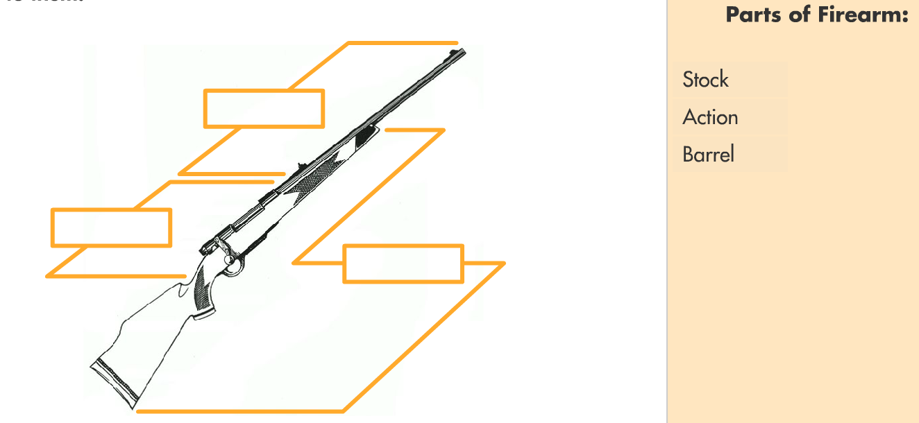

Match the types of action with the method to operate them:
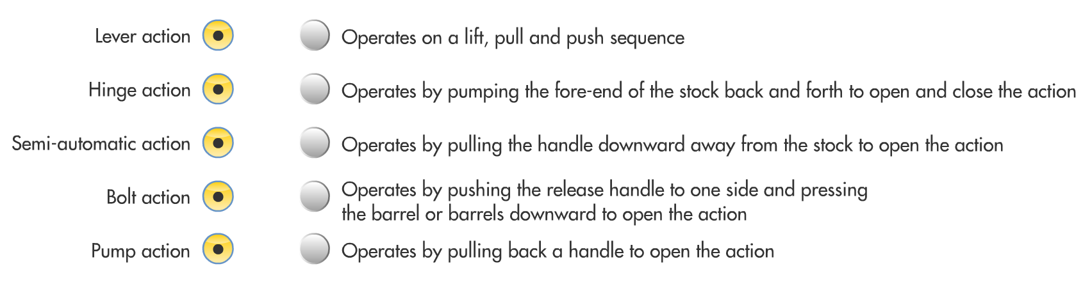

Match the types of sights with the method to operate them:
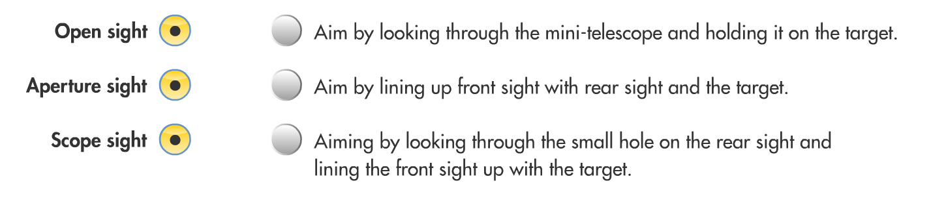
Short answer (write on the back of this page):

- What is the smallest or tightest pattern that a shotgun produces at a given distance?
- What are the major parts of a rifle cartridge/shotgun shell?
- What are the 3 main types of cartridge used today?
- Explain when you would need to clean your gun.
- What is the safest way to carry a firearm?
- When should a firearm be unloaded?

