Heat and Temperature - Quiz 2: Topics 5, 6 and 7. /
Take your time. Read each question carefully.

Matching (10 marks)
Put the correct LETTER beside the number in column A that fits the description.

 | A | B
___ | 1. A material that efficiently transfers thermal energy through conduction. | A. fusion
___ | 2. A process by which a warm fluid moves from place to place carrying thermal energy. | B. radiation
___ | 3. The transfer of energy in the form of electromagnetic waves. | C. thermal conduction
___ | 4. A phase change from a gas directly to a solid. | D. heat insulator
___ | 5. A material that slows the transfer or conduction of thermal energy. | E. heat conductor
___ | 6. An increase in the average temperature of the air on the Earth’s surface. | F. thermal convection
___ | 7. the process of transferring thermal energy through direct collisions between particles. | G. global warming
___ | 8. A method of energy conservation by which waste heat or energy from one industry is used by another industry. | H. cogeneration
___ | 9. The process of changing from a solid to a liquid state. | I. fluids
___ | 10. materials that lack a definite shape and can flow from one place to another | J. deposition

Multiple Choice (10 marks)
CIRCLE the letter of the right answer.

11. Heat capacity is:
(a) a description of a particular object, and depends on the mass and material of the object.
(b) the amount of thermal energy that warms or cools an object by one degree Celsius.
(c) the amount of thermal energy that warms or cools one gram of a material by one degree Celsius
(d) none of the above.

12. If you compress air in a bicycle pump:
(a) It cools down
(b) It warms up
(c) It will likely explode
(d) Trick question! Air cannot be compressed

13. Which of the following is an example of evaporative cooling?
(a) Water vapor in the bathroom after a shower condenses on the mirror.
(b) Sweat on your skin evaporates and takes thermal energy with it.
(c) The lowering of the melting point of water, like when salt is added to ice.
(d) A can painted black absorbs more light than a can painted white, which reflects all the colors of light.

14. The boiling point of a substance is:
(a) The temperature at which liquid matter turns into a gas
(b) The temperature at which solid matter turns into a liquid
(c) The temperature at which gas matter turns into a solid
(d) The temperature at which liquid matter turns into a solid

15. Latent heat is:
(a) The temperature at which liquid matter turns into a gas
(b) The same temperature as the boiling point
(c) The temperature at which gas matter turns into a solid
(d) The energy change that is hidden from thermometers during a phase change.

16. This is an example of chemical energy being used to make thermal energy.
(a) An electric heater is plugged in to heat a cold garage.
(b) The sun warms the sidewalk.
(c) Firewood is burned to keep a house warm.
(d) Wind turns a propeller, which is transformed into electricity by a generator.

17. Geothermal energy is:
(a) The energy of moving air
(b) Energy from the sun
(c) Energy generated in the interior of Earth
(d) All of the above

18. Which of the following is a common characteristic of electromagnetic waves:
(a) They cannot be absorbed or reflected by objects
(b) They behave like waves
(c) They travel across empty space at the speed of 300 km/s
(d) All of the above

19. When a substance changes state, the arrangement of the particles changes. Which of the following statements is false with regard to the particle model of matter?
(a) As the thermal energy increases, particles become less organized and more spread apart.
(b) As thermal energy decreases, particles become more organized and closer together.
(c) the temperature (i.e. the average speed of the particles) changes during a phase change.
(d) the temperature (i.e. the average speed of the particles) stays the same during a phase change.

20. If global warming raises the temperature of the Earth even a few degrees:
(a) it could change climatic zones and their plant growing abilities.
(b) it could dry up rivers and lakes.
(c) It could melt the polar ice caps.
(d) all of the above

Short Answer (10 marks total)

21. List the five features that are common to all energy transfer systems. (the first one is given to you) (4 marks)

- ENERGY SOURCE___________________________________________

- ___________________________________________________________

- ___________________________________________________________

- ___________________________________________________________

- ___________________________________________________________
22. Name 2 problems with using fossil fuels. (2 marks)

- ___________________________________________________________

___________________________________________________________

- ___________________________________________________________

___________________________________________________________

23. Fill in the blanks beside the diagram below. (4 marks)

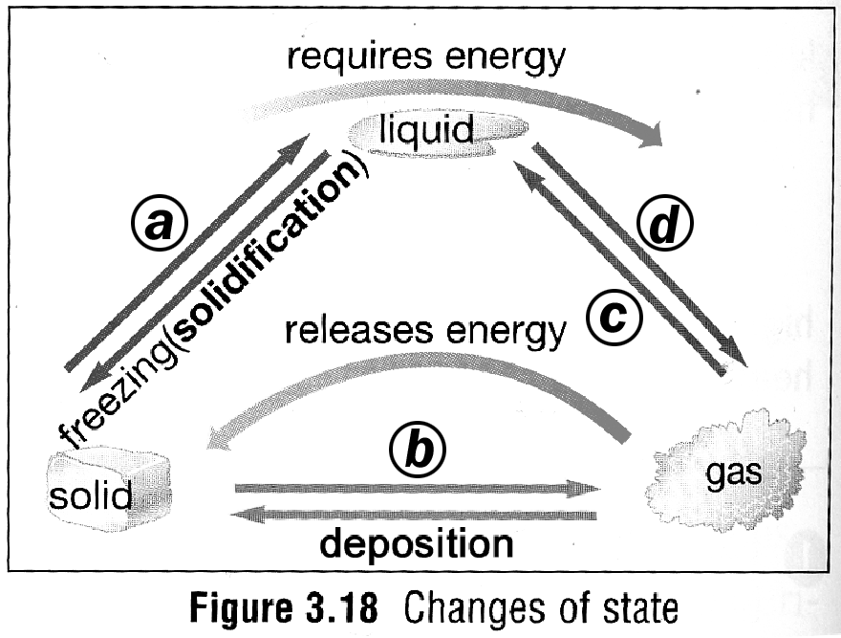
a) ___________________

b) ___________________

c) ___________________

d) ___________________

BONUS: (2 marks)

- According to your textbook, most of the planet Jupiter is made up of a strange substance:

LIQUID METALLIC ________________________________________.

- A technique for using geothermal energy is called HDR. What does HDR stand for?

__________________ _________________ _________________

