Heat and Temperature - Quiz 1: Topics 2,3 and 4. /23
Take your time. Read each question carefully.

Matching (8 marks)
Put the correct LETTER beside the number in column A that fits the description.

 | A | B
___ | 1. Mechanical or electrical devices for measuring temperature | A. Sensor
___ | 2. A pointer, a light, or other mechanism that uses a signal in some way. | B. Signal
___ | 3. A measure of something’s ability to do work, or to cause change. | C. Responder
___ | 4. A series of equally divided sections that are marked and numbered for use in measurement. | D. Particle Model of Matter
___ | 5. heat energy, or the energy generated by the movement or vibration of particles | E. Thermal Energy
___ | 6. A material which is affected by changes in some feature of the environment, such as temperature | F. Temperature
___ | 7. The average kinetic energy of the particles in a substance | G. Scale
___ | 8. Information about temperature, such as an electric current | H. Energy
___ | 9. A scientific model of the structure of matter | I. Thermometers

Multiple Choice (10 marks)
CIRCLE the letter of the right answer.

10. Solids, liquids and gases typically _____________ when heated and
_____________ when cooled. The exception to this rule is water, which
_____________ when it freezes.
(a) contract, expand, contracts
(b) expand, contract, expands
(c) expand, contract, contracts
(d) contract, expand, expands

11. What unit is energy measured in?
(a) Kilograms
(b) Watts
(c) Joules
(d) Newtons

12. On the Celsius scale, the melting point of water is:
(a) -273.15 ºC
(b) 0 ºC
(c) 100 ºC
(d) 273.15 ºC

13. On the Kelvin scale, absolute zero is
(a) -273.15 K
(b) 0 K
(c) 100 K
(d) 273.15 K

14. What is the “signal” of a bimetallic strip thermometer?
(a) The two wire tips.
(b) The electrical current generated between the wire tips.
(c) The tightening or loosening of the coil
(d) None of the above.

15. If you were located high up in the mountains, the air pressure would be:
(a) high and thus water boils at a higher temperature than 100 ºC
(b) high and water would boil at a lower temperature than 100 ºC
(c) low and water would boil at a lower temperature than 100 ºC
(d) low and water would boil at a higher temperature than 100 ºC

16. According to the particle model of matter, as temperature increases:
(a) the motion of the particles in an object increases.
(b) the motion of the particles in an object decreases.
(c) the motion of the particles stays the same.
(d) the average speed of particles decreases.
17. Energy is transferred
(a) in the form of tiny particles that have mass and volume.
(b) in the form of electricity and light only.
(c) from something with low energy to a high energy source.
(d) from a high energy source to something with low energy.

18. The Law of Conservation of Energy states:
(a) Energy is an invisible substance called caloric fluid that causes changes in temperature.
(b) Energy cannot be created or destroyed.
(c) It can only be transformed from one type to another or passed from one object to another.
(d) a and b
(e) b and c

19. Under high pressure conditions, the freezing point of water:
(a) goes up
(b) goes down
(c) stays the same
(d) none of the above. Water does not freeze.

Short answer: (4 marks)

20. List the 4 main points that describe the Particle Model of Matter.

- ________________________________________________________________

________________________________________________________________

- ________________________________________________________________

________________________________________________________________

- ________________________________________________________________

________________________________________________________________

- ________________________________________________________________

________________________________________________________________

BONUS: (1 mark)
The idea that all matter is made of particles was first proposed about 2400 years

ago in ____________________________________________. (name of country)

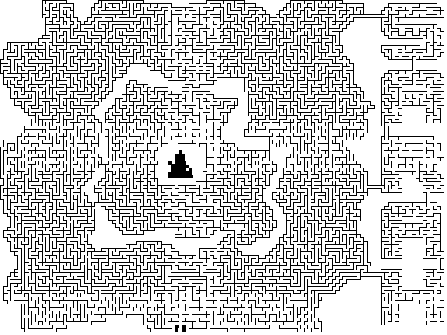
Enter here

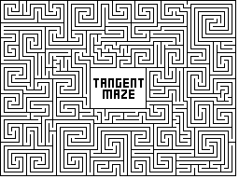
Enter here

