Biomagnification Simulation
Background:
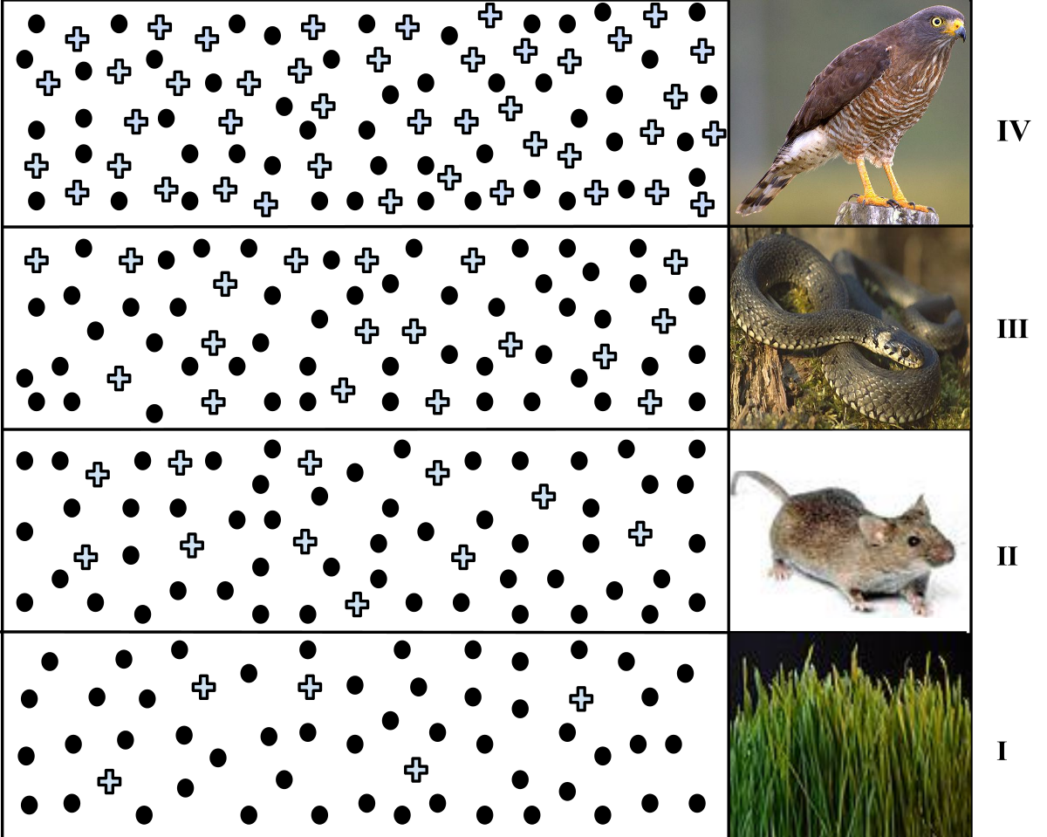
Many forms of pollution can threaten biodiversity, but one of the most serious problems
occurs when toxic compounds accumulate in the tissues of organisms. This
phenomenon is referred to as bioaccumulation.

When heavy metals, such as mercury and lead, and certain synthetic compounds like
pesticides and herbicides are absorbed in the body along with food and water, they
dissolve in the lipids of the organism and are not removed by excretion. Every time an
organism eats a contaminated food, small amounts of the toxin are absorbed and
retained in the body. Small amounts of toxins are consumed over time and they gradually
accumulate which causes toxic effects on the body. Biomagnification occurs as these
effects are compounded throughout a food chain.

Objective: In this activity, you will simulate the biomagnification of a chemical throughout an ecosystem. You will then determine which organisms are most affected by the chemical.

Part 1 – Biomagnification of DDT

- 1 bag with Skittles or other candy | population of primary producers (contaminated with DDT)  Ex: Grain, Corn, Soy Beans, etc
- 8 Small clear plastic cups | Insect
- 4 Small blue paper cups | Spider
- 2 medium clear plastic cups | Sparrow
- 1 Large cup | Sparrow Hawk

SET UP:
- The Skittles in the plastic bag represent the producer population. Each skittle is one contaminated producer.
- First row: Line up 8 small clear cups
Don’t eat the skittles!
- Second row: Line up 4 small blue paper cups
- Third row: Line up 2 medium clear plastic cups
- Fourth row: Line up 1 large cup

PROCEDURE
- Now, simulate Insects eating some of the producers. Remove 3 skittles from the plastic bag and place them into one of the small cups.

- Repeat step 1 for the remaining seven small cups. In your data table record the amount of DDT in each insect.

- Now, simulate the spider eating insects. Each spider needs to eat 2 insects. Empty the contents of 2 small cups into one of the blue paper cups. Repeat for the remaining blue cups. In your data table record the amount of DDT in each spider.

- Simulate a sparrow eating spiders. One sparrow needs to consume 2 spiders. Empty the contents of the 2 blue paper cups into the medium plastic cup. Repeat this step for the other birds as well. In your data table record the amount of DDT in the sparrow.

- Finally, simulate a sparrow hawk eating a sparrow. One sparrow hawk needs to consume 2 sparrows. Empty the contents of the 2 medium clear cups into the large cup. In your data table record the amount of DDT in the Fox.

Biomagnification Simulation

DATA TABLE
Sparrow
Record amount of skittles per organism.
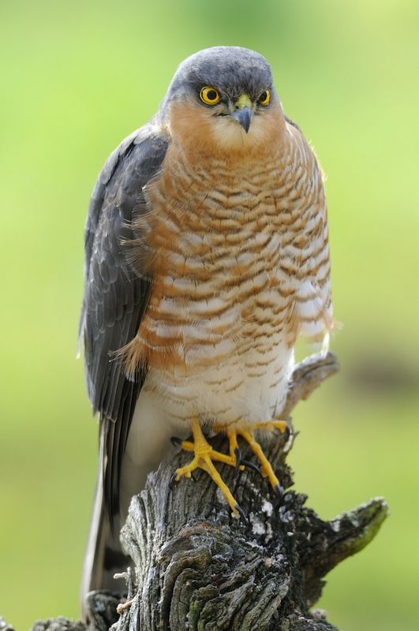
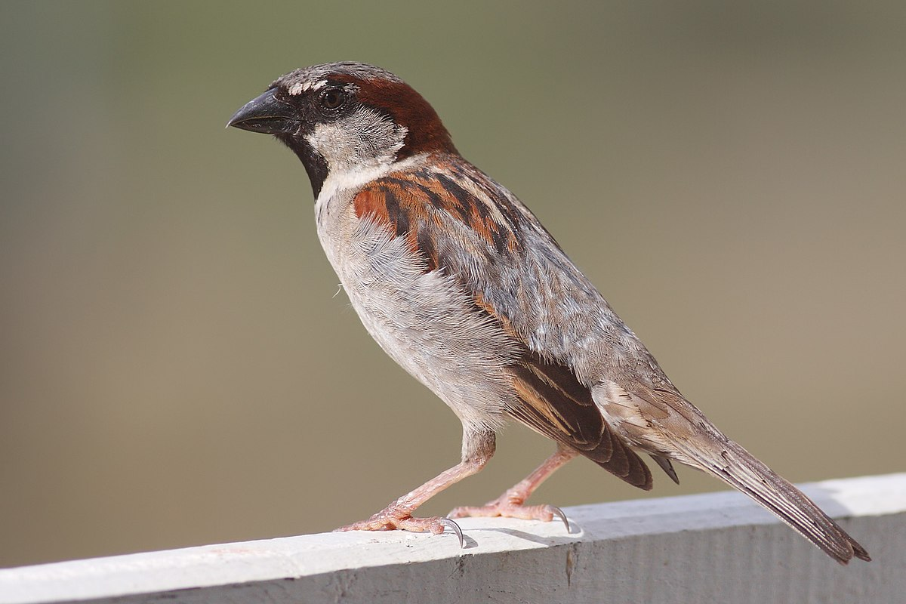
AMOUNT OF MERCURY PER ORGANISM
ORGANISM | AMOUNT OF SKITTLES
Insect
Spider
Sparrow
Sparrow Hawk
Sparrow Hawk

Analysis Questions
- Draw a food chain showing all of the organisms represented in part 1 of this activity.
  - Include consumer level
  - Trophic level (this is review from Unit A: Interactions & Ecosystems)

Biomagnification Simulation

- What happened to the amount of DDT per organism as you move up the food chain?

- Which organism contained the largest concentration of DDT? Explain your reasoning. Consider other food this organism ate and what you can assume about DDT concentration.

- Explain in your own words (using the simulation) biomagnification.

Biomagnification Simulation
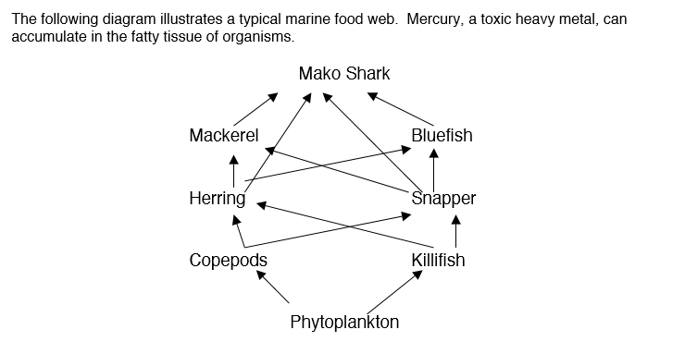

- Which organism would you predict to have the highest level of mercury? Explain your answer.

- Of the following types of fish, which would be the safest to eat? Explain your answer.
Mackerel Snapper Mako Shark Bluefish

