3.1 – DNA & the Genetic Code Date __________________________

DNA is short for ________________________________________________.  It is contained within the ___________________ of a cell and holds all the genetic instructions for that living thing.  1869 - _____________________________________________________________________________  1944 - _____________________________________________________________________________  It appeared that all organisms on Earth had blueprints that were passed on by the same ___________________________. | 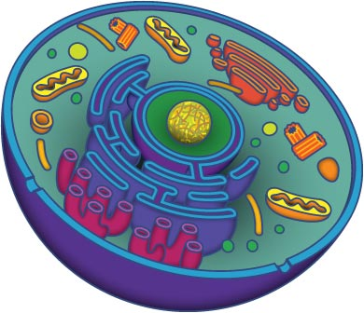
Two scientists, __________________ and ______________ revealed how the same building blocks could carry a ______________________________________________________________ needed for the _____________________ in our world.
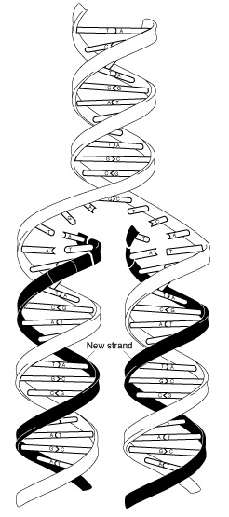 | A DNA molecule (which is contained in the nucleus of a cell) is a ______________ __________, and can be compared to a ladder that has been twisted in a spiral. Each __________ contains 2 chemicals, and they always match to their chemical pair.  The 4 chemicals in all DNA are:  - _______________________ colour: ____________  - _______________________ colour: ____________  - _______________________ colour: ____________  - _______________________ colour: ____________  The way these chemicals are arranged is called our ____________________ ____________. The order of the 4 “letters” (or chemicals) provide all the ________________________ to make an organism. There is so much information in your DNA, that if the DNA from a single cell was stretched out, it would be more than _______________ long.  In order to fit all the information into their cells, _________________________ arrange their ____________ into packages called ___________________________. Each human cell contains _________ chromosome pairs. A chromosome pair has 1 chromosome from EACH parent. This means we have _________ chromosomes in EVERY cell.
WHAT does this have to do with GENETICS?

A single _____________ is an __________________________ segment of DNA. Genes are located on the _______________________ within a cell and contain all the information “coding” us to be who we are both physically and chemically.  Each chromosome pair contains the same ___________ (for example, the chromosome from your mother carries a gene for eye colour, and the chromosome from your father carries a gene for eye colour).  The possible forms that can be taken on are known as ________________. Each allele is marked with an __________ or ___________ case letter indicating whether it is a dominant or recessive trait. | 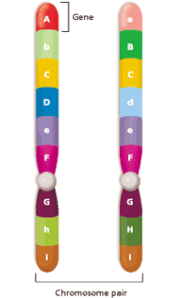

Think Critically: Use the space below to take notes on your group discussion addressing “Jurassic Park” and filling in the genetic code. This will help you with your final challenge at the end of the unit.

