1.2 Optical Devices

Early on, scientists were sure of 1 fact: light has a tendency to __________________ off of some objects and _______________ (commonly referred to as bend – NOT curve) through others. This led to the development of technology that used these properties of light.
Optical Device ______________________________________________________________________________________________________

Microscopes

It was first believed that the microscope was developed in the year _____________ by a father and son team in the Netherlands. It wasn’t until the 17th century however, that a Dutch scientist by the name of _________________________________________ revolutionized the field of _______________________________ with the use of his microscopes.
Using the class website, watch the video on van Leeuwenhoek and read the information on page 182 of the student text to gather information on this early thinker. Use the space below to document your findings.
Van Leeuwenhoek

Microscopes allow you to see an enlarged image of a tiny object by using the power of at least 2 ___________.

REVIEW Use pg 183 and toolbox 11 in your text to label each part of the microscope. Describe how this microscope enlarges an image.
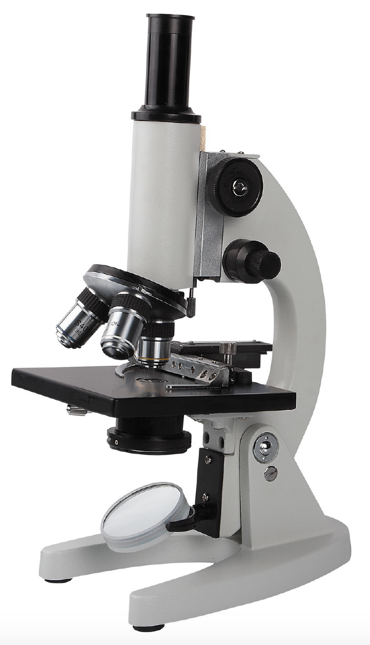

Telescopes:

The invention of the telescope revolutionized the field of astronomy.
The first telescope was invented in the 17th century in the Netherlands; however, the individual most commonly associated with the telescope was an Italian scientist called Galileo Galelei. Galilei developed a telescope known as a ___________________________ telescope.
View the video on the history of telescopes and Galileo's contribution.

Galileo

There are 2 types of optical telescopes:
- ___________________________________ (improved by Galileo Galilei)
- ___________________________________ (created by Isaac Newton)

INTERACTIVE – draw and compare each microscope using the Venn Diagram

